1. **Command Classification** file for python script
2. **Saved the Model as** command_classifier.pkl
3. **Created Flask Application** in VS code
4. **Created requirements.txt file** to list the dependencies
5. **Run the application:**

* **python app.py** 🡪 The app will start and run. It shows “ Welcome to the Command Classifier API!”
* Test the API using curl
* **Input:**
* Invoke-WebRequest -Uri http://127.0.0.1:5000/predict -Method POST -Headers @{ "Content-Type" = "application/json" } -Body '**{"command": "Turn up the brightness"**}'

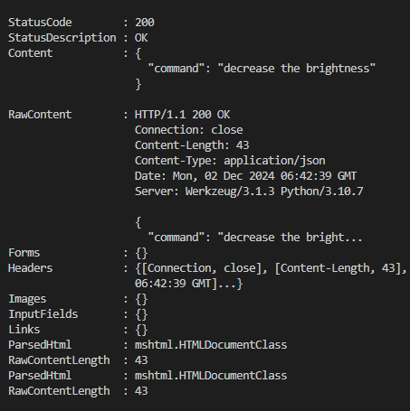

* Open a terminal and use curl to send a POST request to the /predict endpoint.
* -d '{"command": "Turn up the brightness"}': The input data sent to the server.
* **Output:** "command": "increase the brightness"

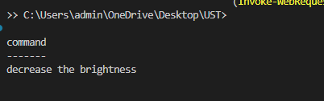

* **Another input:**
* Invoke-WebRequest -Uri http://127.0.0.1:5000/predict -Method POST -Headers @{ "Content-Type" = "application/json" } -Body '**{"command": " Reject the incoming call "**}'
* **Output:** "command": "decline the call"

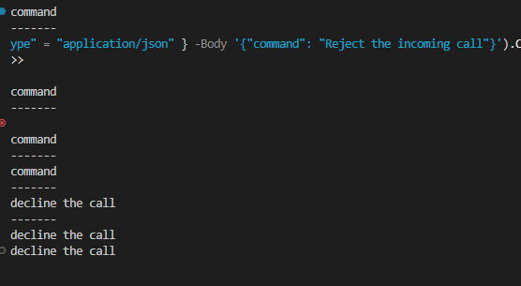

* **Another input:**
* Invoke-WebRequest -Uri http://127.0.0.1:5000/predict -Method POST -Headers @{ "Content-Type" = "application/json" } -Body '**{"command": ""**}'
* **Output:** "error": "No command provided"

